Name: Elza Mary Thomas

Automation Testing Project On E-commerce Application -eBay

**INTRODUCTION:**

Domain Name: E-commerce

Project: Ebay shopping website

In the project, I have tried attempts to successfully automate and achieve my objectives to successfully run the application and have also mentioned the tools used. This involves a brief description of how I achieved my objectives.

**SOFTWARE TESTING LIFECYCLE**

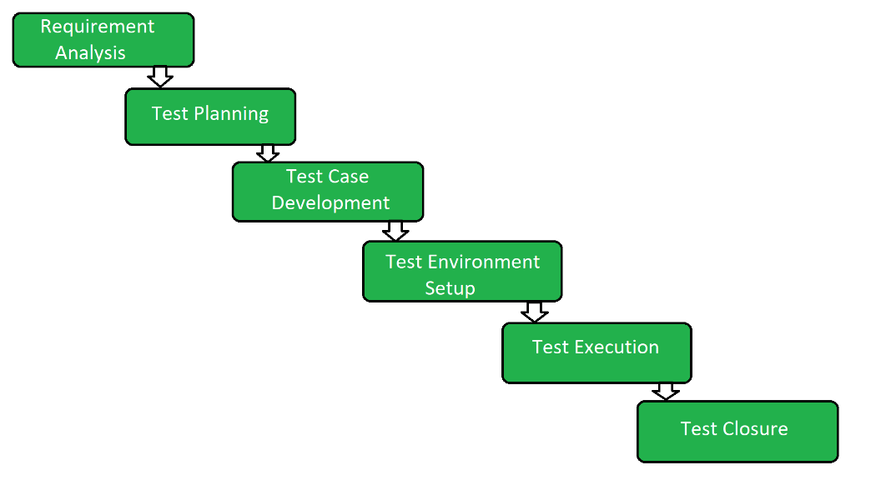

**AUTOMATION TESTING**

**Automation Testing** is a software testing technique that performs using special automated testing software tools to execute a test case suite. On the contrary, Manual Testing is performed by a human sitting in front of a computer carefully executing the test steps.

**SOME BENEFITS OF AUTOMATION TESTING**

*Saves Time*

Automating the testing process helps the testing team to use less time to validate newly created features. For instance, in manual testing, there is a need to write thousand test cases for a calculator application, but automation makes the process much faster.

*Accuracy Improvement*

In manual testing, there is a chance of mistakes whether you are an experienced testing engineer. The chances of errors may increase when testing a complex use case. But Automation testing reduces the chances of errors. There is good accuracy, as we will get the same result each time on performing the same test cases.

*Test Suite Reusability*

We can reuse the test scripts in automation testing, and we don't need to write the new test scripts again and again. These test cases can be used in various ways, as they are reusable. Reusability helps to reduce the cost and also eliminate the chances of human error.

**TECHNOLOGY USED IN THE PROJECT:**

* Selenium Webdriver
* Java
* Maven
* TestNG
* Black Box Testing

-Decision Table Testing

* OOPS

-Inheritance

|  |  |  |  |
| --- | --- | --- | --- |
| Sr.No | HTML Element with steps | Test data and Results | Method Used / Concepts Used |
| *1* | *Launching the App-Ebay (directs to Home Page) and maximised* | *Data:* [*https://www.ebay.com/*](https://www.ebay.com/)  *Result: Launched and verified using Hard Assertions* | *driver.get("https://www.ebay.com/");*  *driver.manage().window().maximize();* |
| *2* | *Scroll to bottom and back* | *Scrolling Operation passed.* | *JavascriptExecutor jse= (JavascriptExecutor)driver;*  *jse.executeScript("window.scroll(0,1900)");*  *Thread.sleep(3000);*  *jse.executeScript("window.scroll(0,-1900)");*  *Thread.sleep(2000);* |
| *3* | *Drop Box Clicking and Element Selection* | *Data: Books*  *Result: Option Books got selected* | *WebElement clickdropdown=driver.findElement(By.xpath("//select[@id='gh-cat']"));*  *clickdropdown.click();*  *Thread.sleep(1000);*    *Select select=****new*** *Select(clickdropdown);*  *select.selectByVisibleText("Books");* |
| *4* | *Verifying Presence of Unique Elements in drop down box* | *Verified presence of unique elementsin drop down* | *List and Sets* |
| *5* | *Verification of App Logo* | *Verified presence of Ebay logo* | **boolean** IsLogoDisplayed=EbayImg(driver,By.*xpath*("/html/body/header/table/tbody/tr/td[1]"));  Assert.*assertTrue*(IsLogoDisplayed);  System.***out***.println("Ebay image is present");  EbayImg is a User defined method that has parameters -driver and locator xpath that returns boolean values. |
| *6* | *Verification of other elements like add to cart symbol and notification bell symbol* | *Verified Presence of add to cart symbol and notification bell symbol.* | **boolean** IscartDisplayed=EbayImg(driver,By.*xpath*("//*[@id=\"gh-minicart-hover\"]/div/a[1]"));  Assert.*assertTrue*(IscartDisplayed);  System.***out***.println("Cart symbol is present");    **boolean** IsNotificationDisplayed=EbayImg(driver,By.*xpath*("//*[@id=\"gh-eb-Alerts\"]/div/button"));  Assert.*assertTrue*(IsNotificationDisplayed);  System.***out***.println("Notification Bell symbol is present\n ");  EbayImg is a User defined method that has parameters -driver and locator xpath that returns boolean values. |
| *7* | *Hovering through different categories in home page* | *Hovering operation successfully executed.* | *Action class, moveToElements() and perform() methods* |
| *8* | *Selecting Country value ‘India’ on Hovering country selection option and Reach expected page and navigate back to parent page.* | *Successfully reached the expected site when clicked on India.* | *JavascriptExecuter interface to scroll down*  *Actions class.*  *moveToElement() and perform() methods*  *Hard Assertions Used* |
| *9* | *Accessing Watchlist Site .Clicking on Watchlist without login and logging in through the signIn link displayed thereafter* | *Successfully captured the message displayed to Login and Successfully logged In. Reached the expected page of watchlist* | driver.findElement(By.*xpath*("//*[@id=\"gh-wl-click\"]/div")).click();    Hard Assertions used |
| *10* | *Sign Out* | *Successfully Signed Out* | driver.findElement(By.*xpath*("//*[@id=\"gh-uo\"]/a")).click();  String SignOutMsg=driver.findElement(By.*xpath*("//*[@id=\"signout-banner-text\"]")).getText();  **if**(SignOutMsg.contains("signed out"))  {  System.***out***.println("Successfully Signed Out");  } |
| *11* | *Search an item and verify the results* | *Successfully searched for item :Laptops*  *And verified the results by displaying total search results found .* | driver.findElement(By.*xpath*("//*[@id=\"gh-ac\"]")).sendKeys("laptops");  driver.findElement(By.*id*("gh-btn")).click(); |
| *12* | *Add to cart the product from new Window* | *Successfully verified the add to cart operation.* | Using WindowHandles and cssLocator of Add To Cart Button  Set<String> windhan=driver.getWindowHandles |
| *13* | *Accessing the Checkout page by logging In* | *Successfully Accessed the Checkout page by logging In* | Using xpath locator  driver.findElement(By.*xpath*("//*[@id=\"mainContent\"]/div/div[3]/div[2]/div/div[1]")).click(); //checkout  Thread.*sleep*(2000);  String hello=driver.findElement(By.*xpath*("//*[@id=\"greeting-msg\"]")).getText();  **if**(hello.contains("Hello"))  {  driver.findElement(By.*xpath*("//*[@id=\"userid\"]")).sendKeys("demoemt23@gmail.com");  System.***out***.println("Successfully enterd userId");  driver.findElement(By.*xpath*("//*[@id=\"signin-continue-btn\"]")).click(); //clicking continue  System.***out***.println("Clicked Continue");  Thread.*sleep*(5000);  }  String welcome=driver.findElement(By.*xpath*("//*[@id=\"welcome-msg\"]")).getText();  **if**(welcome.contains("Welcome"))  {  driver.findElement(By.*xpath*("//*[@id=\"pass\"]")).sendKeys("elz*1568");//Enter password  System.***out***.println("Entered password");  driver.findElement(By.*xpath*("//*[@id=\"sgnBt\"]")) |
| *14* | *Remove Item from Cart and verify it* | *Successfully removed item from cart* | driver.findElement(By.*xpath*("//*[@id=\"mainContent\"]/div/div[2]/div[1]/div[1]/div/ul/li/div[1]/div/div/div[2]/span[2]/button")).click();  Thread.*sleep*(6000);  WebElement removed = driver.findElement(By.*xpath*("//*[@id=\"page-alerts\"]/section/div[2]/h2/span/span"));  System.***out***.println("Message verifying item removal: "+removed.getText()); |
| *15* | *Register /create Account* | *Successfully created Ebay account* | WebElement personalacc = driver.findElement(By.*cssSelector*("#personalaccount-radio"));  personalacc.click();  driver.findElement(By.*xpath*("//input[@id='firstname']")).sendKeys("Elza");  driver.findElement(By.*xpath*("//input[@id='lastname']")).sendKeys("Thomas");  driver.findElement(By.*xpath*("//input[@id='Email']")).sendKeys("demoemt23@gmail.com");  driver.findElement(By.*xpath*("//input[@id='password']")).sendKeys("elzaa*1568");  Thread.*sleep*(2000);  //To click the register button  WebElement registerBtn=driver.findElement(By.*xpath*("/html/body/div[2]/div[3]/div[3]/div/div/div/div/form/div[6]/div/span/button")); |
| *16* | *Screenshot Taking if Test case Failed*  *\*Used Listeners and Inheritance(OOP)* | *Successfully took the screenshot of failed Test case:Tiltle mismatch.* | **public** **void** VerifyTitle()  {  String Title1=*driver*.getTitle();  String Title2="Ebay Shoppings";  Assert.*assertEquals*(Title1, Title2);  } |
| *17.* | *Black Box Testing Technique*  *(Decision Table Testing)* | *Successfully conducted black box testing by providing invalid email id.* | driver.findElement(By.*xpath*("//*[@id=\"userid\"]")).sendKeys("demoemt23gmail.com");  Thread.*sleep*(3000);  driver.findElement(By.*xpath*("//*[@id=\"signin-continue-btn\"]")).click(); //click continue |